BOC API Document
(Others)
“Revert RR”:
- /api/v1.0/repairRequest/RevertRR

- “/api/v1.0/repairRequest/RevertRR”
Open “Front End” codebase”:
Search the API in “restURI.ts” file:
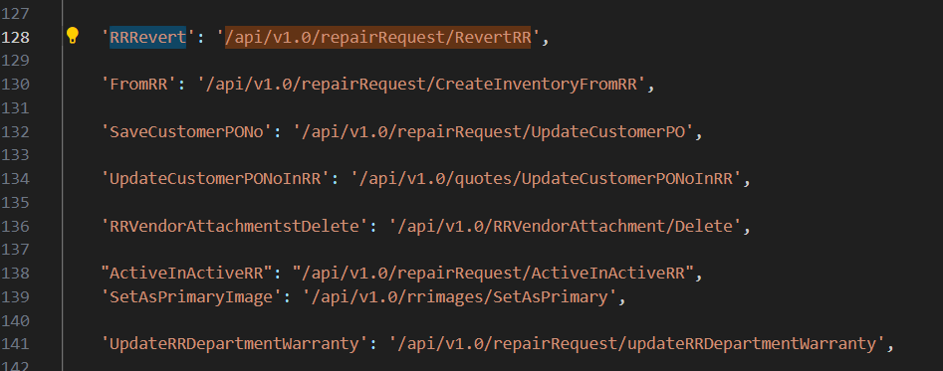
Copy: “RRRevert” to search in frontend.
Open “Back End” codebase:
Open “repairrequest.routes.js”,
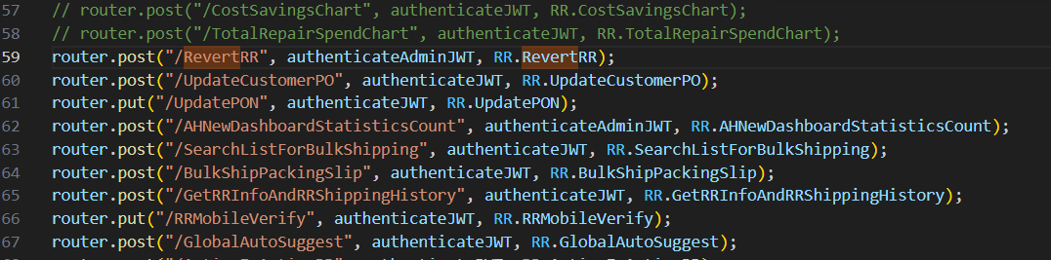
“Right” click on “RR.RevertRR” in line 59, click “Go to Definition”, it shows the code in “repairrequest.controller.js”,
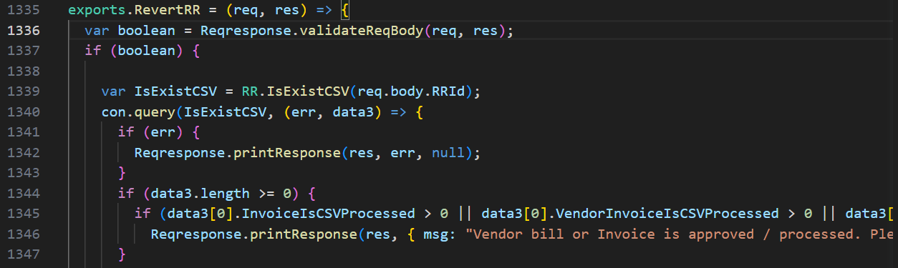
and so on.
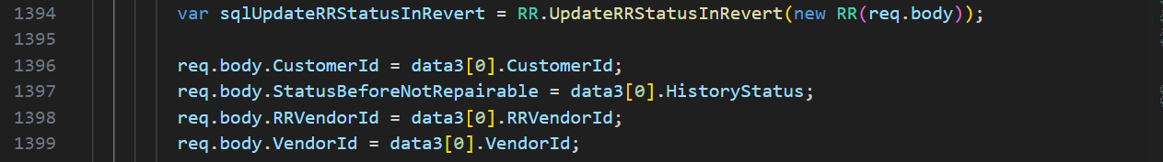
and so on.
“Right” click on “IsExistCSV” in line 1339 in “repairrequest.controller.js”, click “Go to Definition”, it shows its “SQL” codebase in “repairrequest.model.js” in line 3379,
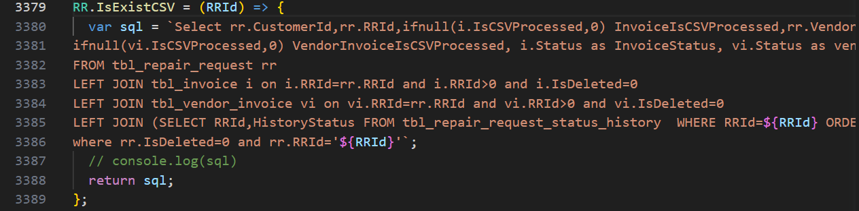
“Right” click on “UpdateRRStatusInRevert” in line 1394 in “repairrequest.controller.js”, click “Go to Definition”, it shows its “SQL” codebase in “repairrequest.model.js” in line 4134,
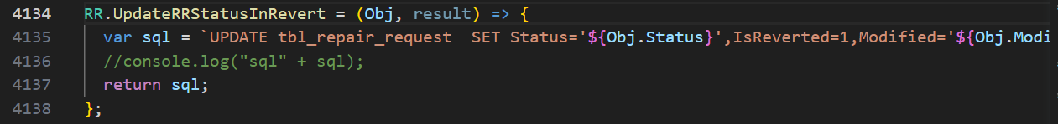

“Add Substatus and Assign to”:
- /users/getAllActiveAdmin
- /api/v1.0/RRSubStatus/dropdown

- “/users/getAllActiveAdmin”: Repeated
- “/api/v1.0/RRSubStatus/dropdown”: Repeated

“Submit”:
- /api/v1.0/repairRequest/WorkchainBulkUpdate
- /api/v1.0/notification/getLatest
- /api/v1.0/repairRequest/WorkchainMyTaskCount
- /api/v1.0/ecommerce/product/cartCount
- /api/v1.0/country/list
- /api/v1.0/repairRequest/view
- /users/getAllActiveAdmin
- /api/v1.0/RRSubStatus/dropdown
- /api/v1.0/currencyExchangeRate/exchange

- “/api/v1.0/repairRequest/WorkchainBulkUpdate”
Open “Front End” codebase”:
Search the API in “restURI.ts” file:
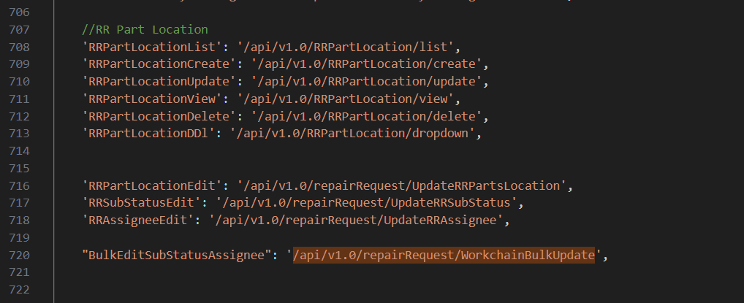
Copy: “BulkEditSubStatusAssignee” to search in frontend.
Open “Back End” codebase:
Open “repairrequest.routes.js”,
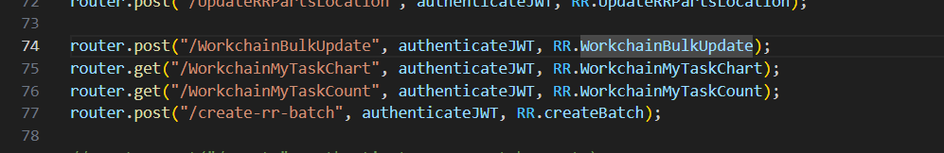
“Right” click on “WorkchainBulkUpdate” in line 74, click “Go to Definition”, it shows the code in “repairrequest.controller.js”,
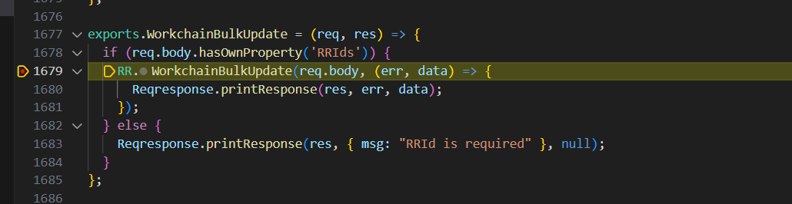
“Right” click on “WorkchainBulkupdate” in line 1679, click “Go to Definition”, it shows its “SQL” codebase in “repairrequest.model.js” in line 4503,
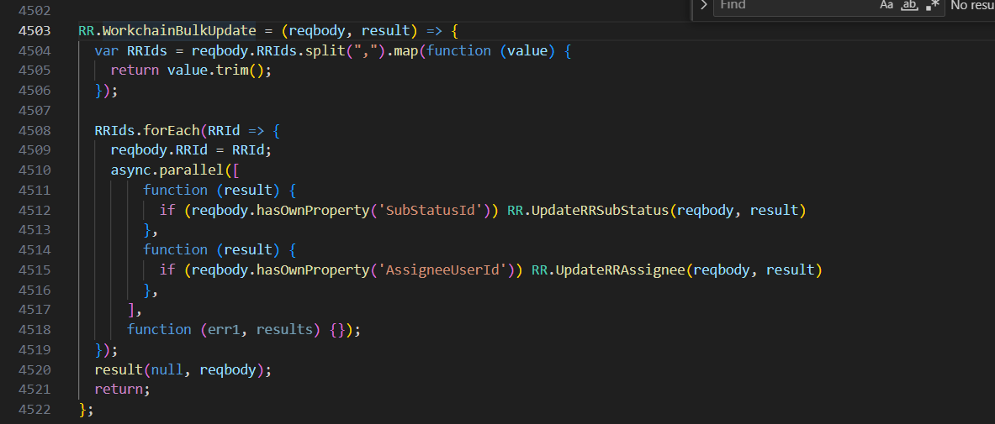

- “/api/v1.0/notification/getLatest”: Repeated
- “/api/v1.0/repairRequest/WorkchainMyTaskCount”: Repeated
- “/api/v1.0/ecommerce/product/cartCount”: Repeated
- “/api/v1.0/country/list”: Repeated
- “/api/v1.0/repairRequest/view” : Repeated
- “/users/getAllActiveAdmin” : Repeated
- “/api/v1.0/RRSubStatus/dropdown” : Repeated
- “/api/v1.0/currencyExchangeRate/exchange” : Repeated

“Not Repairable: Submit: Yes”:
- /api/v1.0/repairRequest/RRNotRepairable
- /api/v1.0/notification/getLatest
- /api/v1.0/repairRequest/WorkchainMyTaskCount
- /api/v1.0/ecommerce/product/cartCount
- /api/v1.0/country/list
- /api/v1.0/repairRequest/view
- /users/getAllActiveAdmin
- /api/v1.0/RRSubStatus/dropdown
- /api/v1.0/currencyExchangeRate/exchange

- “/api/v1.0/repairRequest/RRNotRepairable”
Open “Front End” codebase”:
Search the API in “restURI.ts” file:
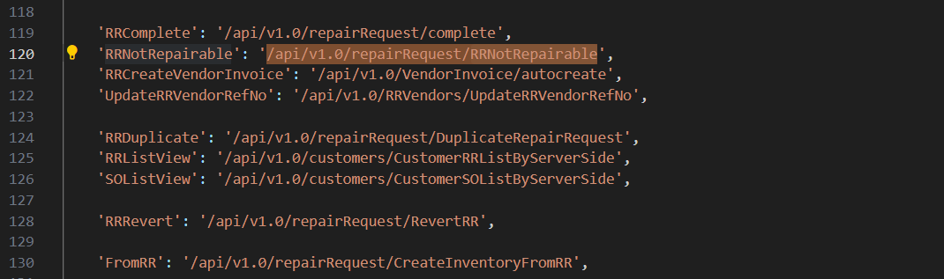
Copy: “RRNotRepairable” to search in frontend.
Open “Back End” codebase:
Open “repairrequest.routes.js”,
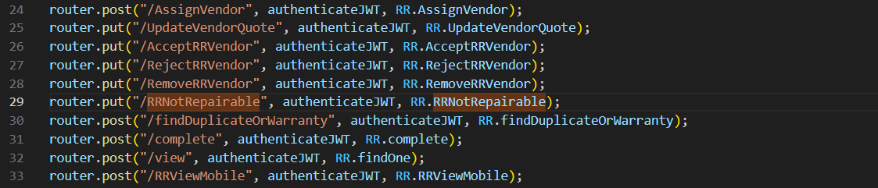
“Right” click on “RR.RRNotRepairable” in line 29, click “Go to Definition”, it shows the code in “repairrequest.controller.js”,
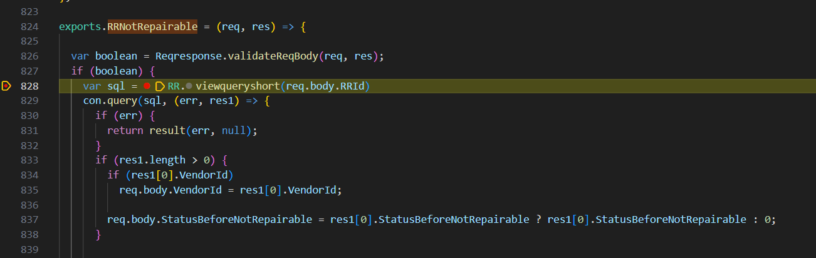
“Right” click on “Viewqueryshort” in line 828, click “Go to Definition”, it shows its “SQL” codebase in “repairrequest.model.js” in line 801,

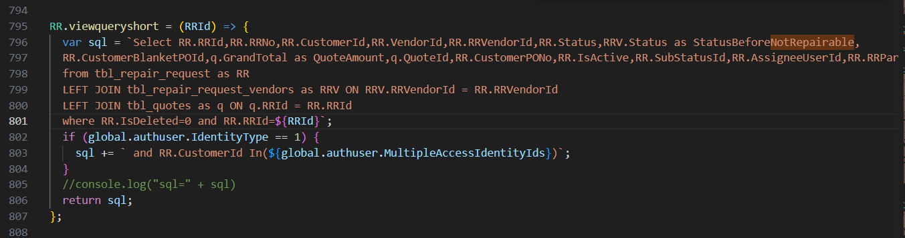

- “/api/v1.0/notification/getLatest”: Repeated
- “/api/v1.0/repairRequest/WorkchainMyTaskCount”: Repeated
- “/api/v1.0/ecommerce/product/cartCount”: Repeated
- “/api/v1.0/country/list”: Repeated
- “/api/v1.0/repairRequest/view” : Repeated
- “/users/getAllActiveAdmin” : Repeated
- “/api/v1.0/RRSubStatus/dropdown” : Repeated
- “/api/v1.0/currencyExchangeRate/exchange” : Repeated

“RR Log”:
- /api/v1.0/notification/getRRNotificationList

- “/api/v1.0/notification/getRRNotificationList”
Open “Front End” codebase”:
Search the API in “restURI.ts” file:
Copy: “RRLog”.
Open “Back End” codebase:
Open “notification.routes.js”,
“Right” click on “Notification.getRRNotificationList” in line 13, click “Go to Definition”, it shows the code in “notification.controller.js”,
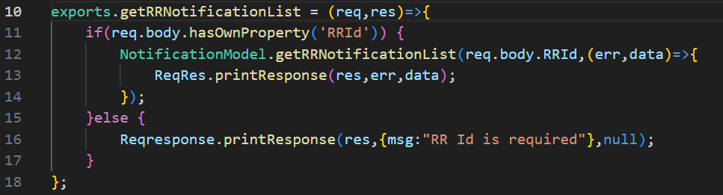
“Right” click on “getRRNotificationList” in line 12, click “Go to Definition”, it shows its “SQL” codebase in “notification.model.js” in line 53,
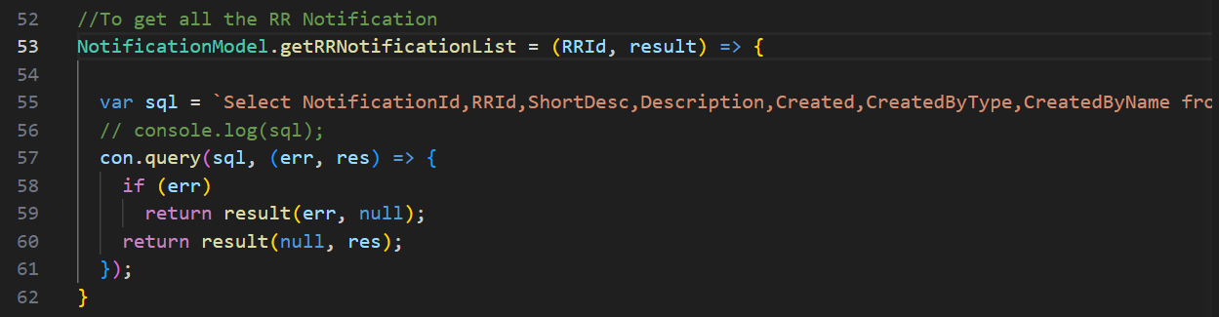

“Vendor Quote Rejection: Submit: Yes”:
- /api/v1.0/repairRequest/RejectRRVendor
- /api/v1.0/notification/getLatest
- /api/v1.0/repairRequest/WorkchainMyTaskCount
- /api/v1.0/ecommerce/product/cartCount
- /api/v1.0/country/list
- /api/v1.0/repairRequest/view
- /users/getAllActiveAdmin
- /api/v1.0/RRSubStatus/dropdown
- /api/v1.0/currencyExchangeRate/exchange
- /api/v1.0/address/GetAHGroupVendorAddress

- “/api/v1.0/repairRequest/RejectRRVendor”
Open “Front End” codebase”:
Search the API in “restURI.ts” file:
Copy: “RRVendorQuoteReject”.
Open “Back End” codebase:
Open “repairrequest.routes.js”,
“Right” click on “RR.RejectRRVendor” in line 27, click “Go to Definition”, it shows the code in “repairrequest.controller.js”,
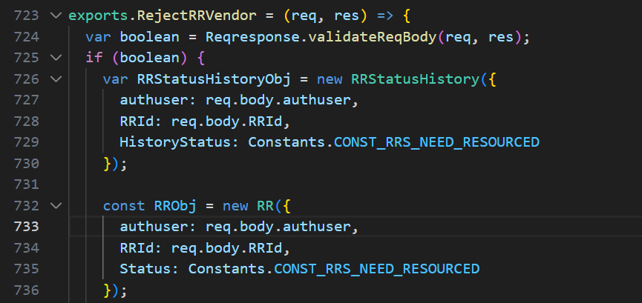
and so on.
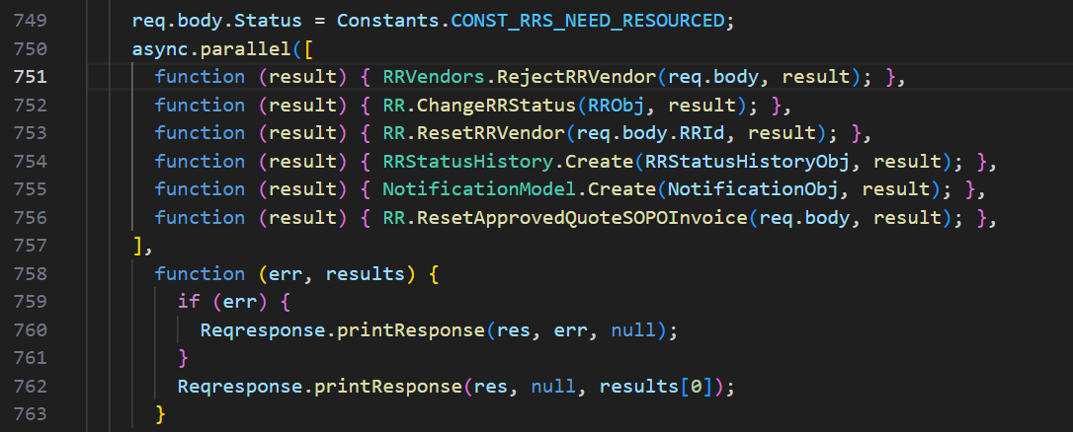
and so on.
“Right” click on “RejectRRVendor” in line 751, click “Go to Definition”, it shows its “SQL” codebase in “repair.request.vendors.model.js” in line 170,
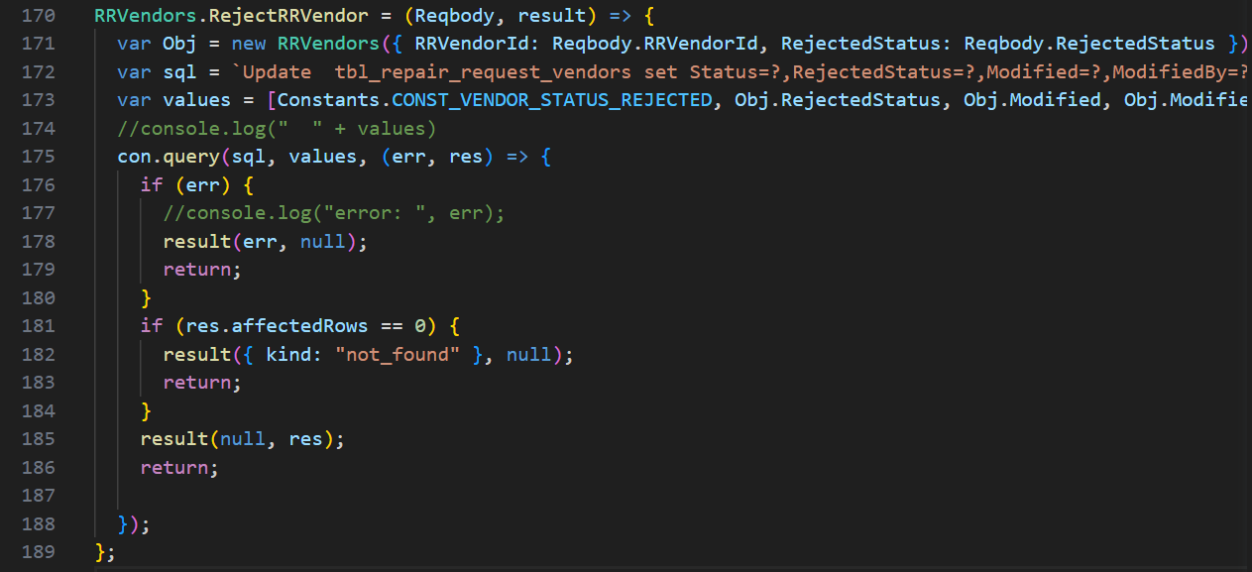

- “/api/v1.0/notification/getLatest”: Repeated
- “/api/v1.0/repairRequest/WorkchainMyTaskCount”: Repeated
- “/api/v1.0/ecommerce/product/cartCount”: Repeated
- “/api/v1.0/country/list”: Repeated
- “/api/v1.0/repairRequest/view” : Repeated
- “/users/getAllActiveAdmin” : Repeated
- “/api/v1.0/RRSubStatus/dropdown” : Repeated
- “/api/v1.0/currencyExchangeRate/exchange” : Repeated
- “/api/v1.0/address/GetAHGroupVendorAddress” : Repeated

